**Final Term Paper (Spring-2022)**

**BSCS/BSIT/BSSE (Morning/Evening)**

**Computer Networks ( CS-577 )**

**Maximum Marks: 30 (Theory) Total Time: 1Hr45min**

**Question N0. 1: [Marks: 6]**

Consider the network shown below and assume that each node initially knows the costs to each of its neighbors. Use the distance vector algorithm and complete the entire distance table below as it would look like at node *2* after the algorithm has converged.

|  |  |  |  |  |  |  |  |
| --- | --- | --- | --- | --- | --- | --- | --- |
| **Distance Vecortable at node 2** | | **Cost to destination node** | | | | | |
| **0** | **1** | **2** | **3** | **4** | **5** |
| **Distance Vector from neighbor** | **0** |  |  |  |  |  |  |
| **1** |  |  |  |  |  |  |
| **2** |  |  |  |  |  |  |
| **3** |  |  |  |  |  |  |
| **4** |  |  |  |  |  |  |
| **5** |  |  |  |  |  |  |

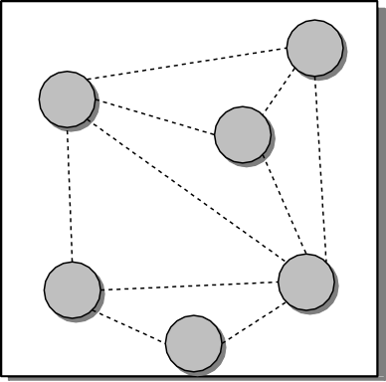

0

**1**

4

**1**

**1**

1

**7**

**3**

**4**

**1**

3

2

**3**

**2**

5

**2**

**Question N0. 2: [Marks: 6]**

Network Administrator assign you the task to create four separate networks of subnets for newly established University campus in Islamabad. Available network ID is 200.170.10.0/24.

* One subnet is for the UIIT department. . One is for UIMS department.
* One is for FCFS department. . One is for Controller of Examination department.

UIIT needs IP’s for 64 students, UIMS needs 50, other two department has no specific requirement. Your task is to list each Network ID, Subnet Mask, Host Range, Number of usable Host ID’s and Broadcast ID.

**Question N0. 3: [Marks: 3+3]**

1. Suppose Node A want to send 40000 Bytes of data (at application layer) to Node B in the form of packets, each packet can contain maximum 5000Bytes at layer2 including headers, assume three headers (Layer 2, Layer 3 and Layer 4 with TCP) are attached. Time to reach one packet from A to B is 10ms then using stop and wait protocol, how much time required to transmit all 40000 Bytes of data?

**(b)** The OSI is reference/conceptual model and accordingly multiple practical models (such as TCP/IP, AppleTALK, etc) exits. Which fundamental functionalities necessarily needs to considered while implementing any network model?

**Question N0. 4: [Marks: 6]**

Within the Data Link Layer, we studied a variety of Medium Access Control (MAC) protocols to regulate access to a broadcast channel shared by many stations. For each of the Random Access MAC protocols, provide a brief description (either algorithmic or conceptual) of how it works. Where possible, clarify the new features in each protocol that improve upon the MAC protocols earlier in the list.

**Question N0. 5: Answer the following questions (Maximum 6 lines for each part)? [Marks: 6]**

1. Compare and contrast flow control and error control
2. Name the advantages of optical fiber over twisted-pair and coaxial cable.
3. Differentiate between Go back N and Selective repeat protocol